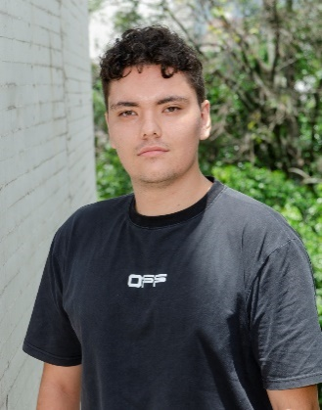

**Computer Scientist**

**Juan José Gabriel Cañón Díaz**

|  |
| --- |
| [jjcanond@eafit.edu.co](mailto:jjcanond@eafit.edu.co) |
| Celular: 3204615698 |
| Ciudad: Medellín |
| [LinkedIn](https://www.linkedin.com/in/juanjosecannon) | [GitHub](https://github.com/JJCanon) |

|  |  |
| --- | --- |
| **Profile** | **Formal Education** |
| Computer Scientist student with an interest in AI, data science, and backend development. Experience with Django, React, and databases. Certified in analytics and data science. Strong technical and analytical skills, with a focus on innovative solutions. | * Computer Science EAFIT University   2019 – current |

|  |  |
| --- | --- |
| **No Formal Education** | **Experience** |
| * Artificial Intelligence Fundamentals – IBM SkillsBuild   2025   * Data Fundamentals – IMB SkillsBuild   2025   * Introducción a Data Science – IPSDATAX   2025 – Currently | * AgroMerc Proyect – Full Stack Development   2024 – Medellín   * [Repositorio GitHub P1](https://github.com/JJCanon/P1-AgroMerc) | [Repositorio GitHub v2](https://github.com/JJCanon/AgroMerc_TopIngSoft) |
| * Data Science Repository – Self-taugth   2025 – Medellín   * <https://github.com/JJCanon/Data-Science> |
| * Colaborative proyect – Backend Developer   2025 – Medellín   * [Repositorio GitHub](https://github.com/JeroZp/P2) * Task Automated – Data Scientist   2025 – Medellín   * [Automate Process](https://github.com/JJCanon/automate_processes) * Salary Predictor   2025 – Medellín   * [Salary Predictor](https://github.com/JJCanon/Salary_predict) |

|  |  |
| --- | --- |
| **Skills** | **Systems and Languages** |
| * Teamwork * Comunication Skills * Python, Java, C++, JavaScript * DataBases * Visualization * Cloud & DevOps * Responsibility * Time Management | * Microsoft Office (Medio) * Power BI (Medio) * Azure * GitHub * English (B1) |

|  |  |
| --- | --- |
| **Actividades extracurriculares** |  |
| * Semillero de Machine Learning (EAFIT, 2025). |  |